**OrthoAnalyzer**

**PATIENT**

**CASE**

**• ID:** 2201335300

**• SSN:**

**• Name:** Abinaya

**• Address:**

**• City:**

**• Country:** INDIA

**• Clinic ID:**

**• ID:** 2201335300

**• Operator:** DR. Arathy L.R

**• Comment:**

**• Date:** 24‑01‑2022

**• Scan date:** 24‑01‑2022 12:14:17

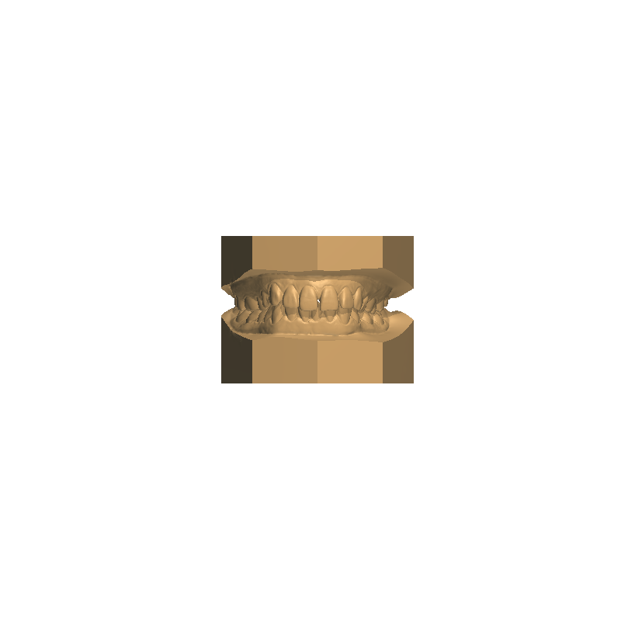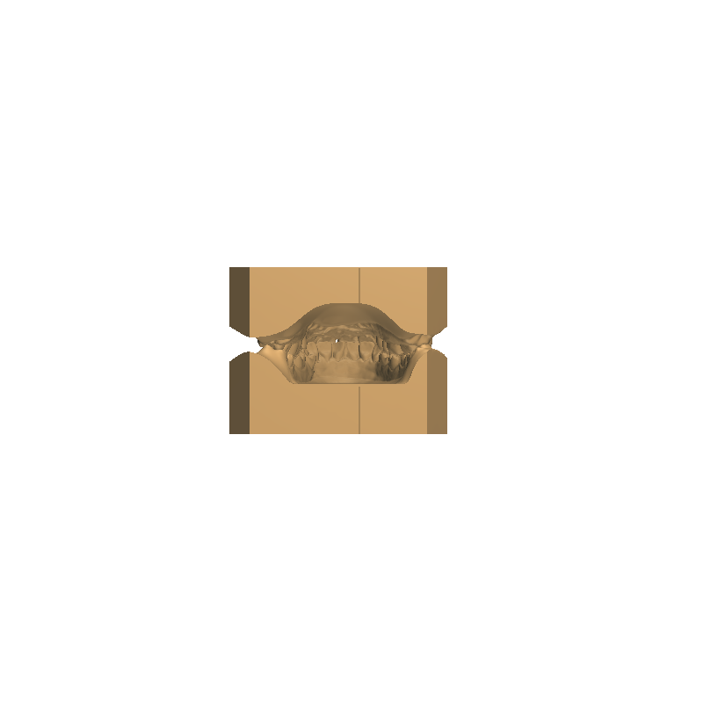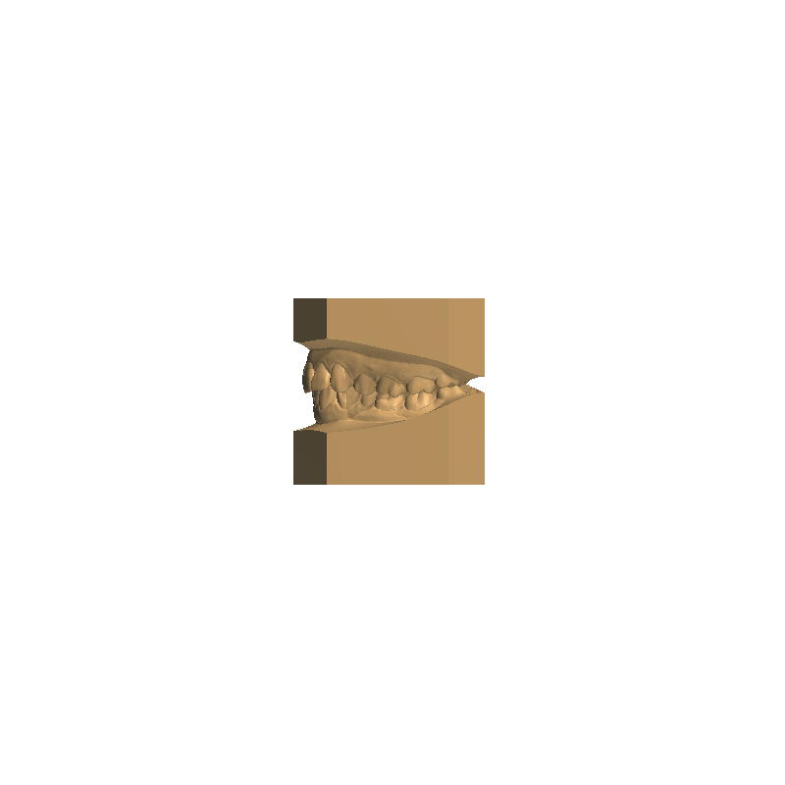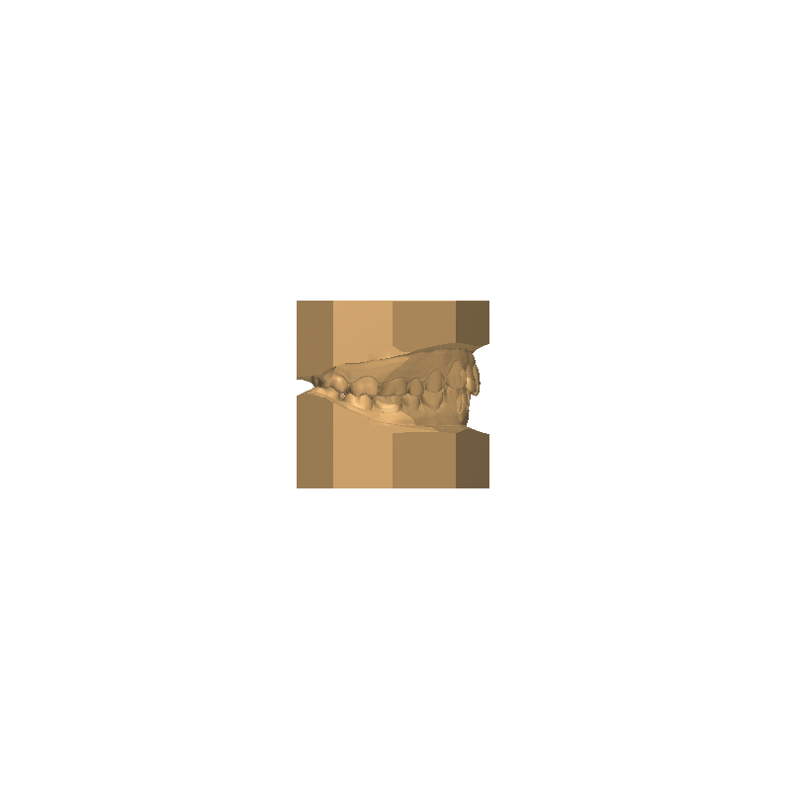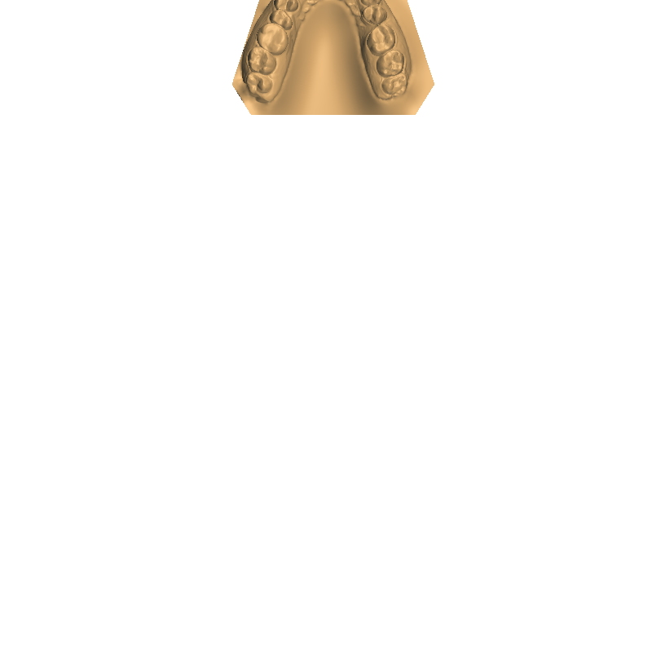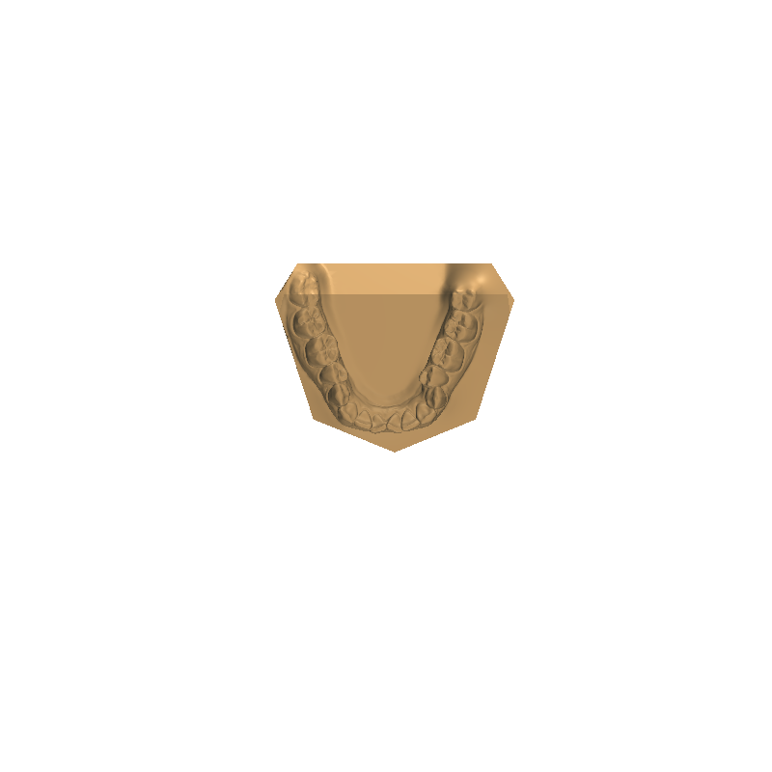Page 1 of 11



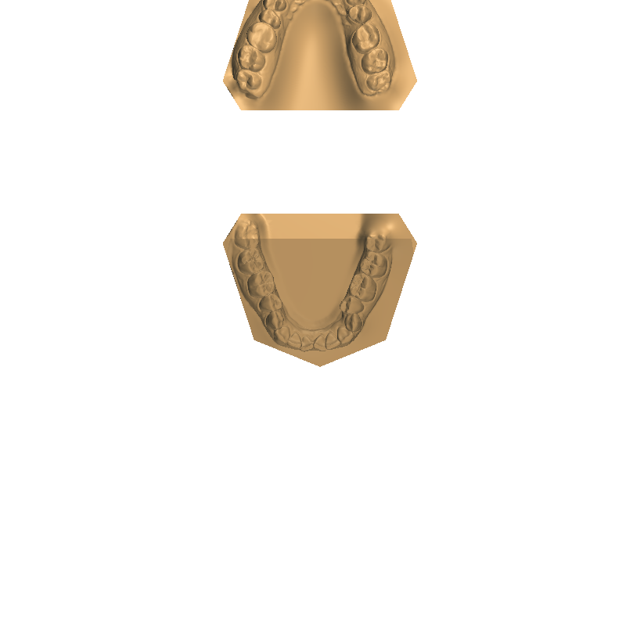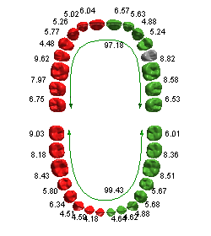**Overview**

**Ideal curve**

0

**Ideal length**

0

**Bracket offset_length**

**•**

**•**

**Ideal arch analysis**

**OVERALL BOLTON ANALYSIS**

*Ideal ratios*

*Maxillary 6 width:*

*Mandibular 6 width:*

*Ratio:*

**•**

**•**

**•**

**•**

Page 2 of 11



**Default**

Table:

**Tooth width analysis**

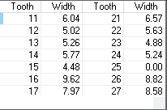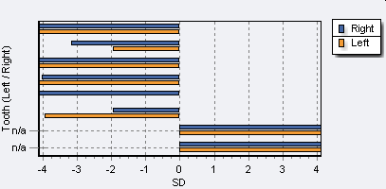**MAXILLARY TOOTH WIDTH ANALYSIS**

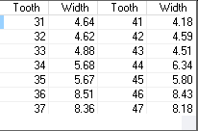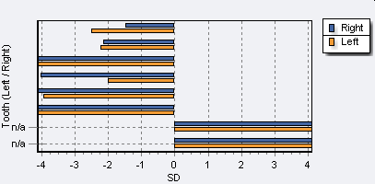**MANDIBULAR TOOTH WIDTH ANALYSIS**

**OVERALL BOLTON ANALYSIS**

*Ideal ratios*

*Maxillary 6 width:*

*Mandibular 6 width:*

*Ratio:*

**•**

**•**

**•**

**•**

Page 3 of 11



**ANTERIOR BOLTON ANALYSIS**

*Maxillary 6 width:*

*Mandibular 6 width:*

*Ratio:*

1

27

33

*Ideal ratios*

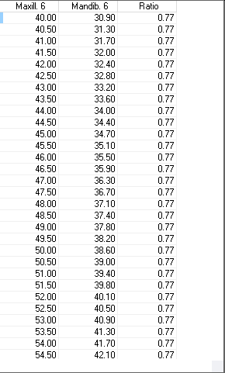**•**

**•**

**•**

**•**

**Bolton analysis**

**OVERALL BOLTON ANALYSIS**

67

68

1

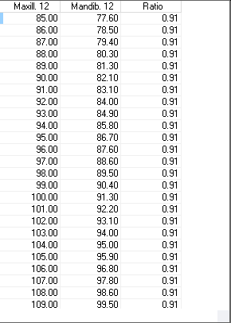*Ideal ratios*

*Maxillary 6 width:*

*Mandibular 6 width:*

*Ratio:*

**•**

**•**

**•**

**•**

Page 4 of 11



**OVERALL BOLTON ANALYSIS**

*Ideal ratios*

*Maxillary 6 width:*

*Mandibular 6 width:*

*Ratio:*

**•**

**•**

**•**

**•**

**Default**

Table:

**Space analysis**

**MAXILLARY SPACE ANALYSIS**

*Total space available:*

23

49

*Sum of left canine & premolars:*

1

*Sum of right canine & premolars*

*Total space required*

*Discrepancy*

**Moyers**

**Tanaka & Johnston**

1

1

1

20

20

63

‑14

**•**

**•**

**•**

**•**

**•**

**•**

*Sum of left canine & premolars:*

*Sum of right canine & premolars*

*Total space required*

*Discrepancy*

**•**

**•**

**•**

**•**

*Sum of incisor widths*

**MANDIBULAR SPACE ANALYSIS**

18

51

1

1

1

1

20

20

57

‑6

*Total space available:*

*Sum of incisor widths*

**•**

**•**

*Sum of left canine & premolars:*

*Sum of right canine & premolars*

*Total space required*

*Discrepancy*

**Moyers**

**•**

**•**

**•**

**•**

**Tanaka & Johnston**

*Sum of left canine & premolars:*

*Sum of right canine & premolars*

*Total space required*

*Discrepancy*

**•**

**•**

**•**

**•**

**Screen snaphots**

**• Date:** 25‑01‑2022 19:25:56

**• Comment:**

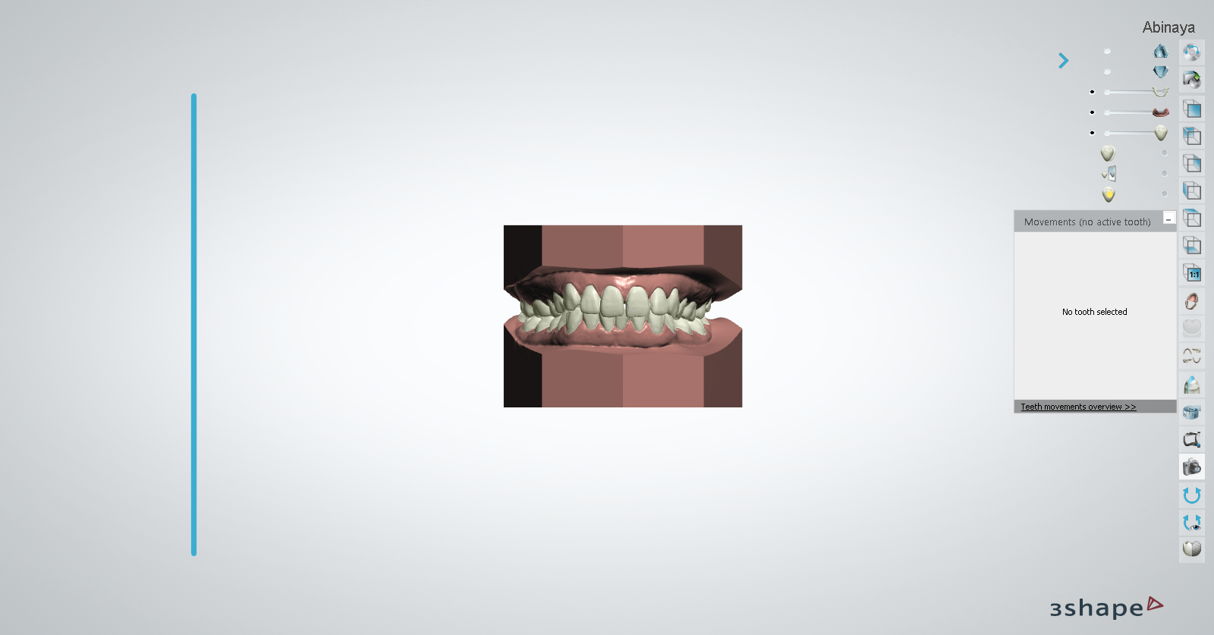**• Date:** 25‑01‑2022 19:26:01

**• Comment:**

Page 5 of 11



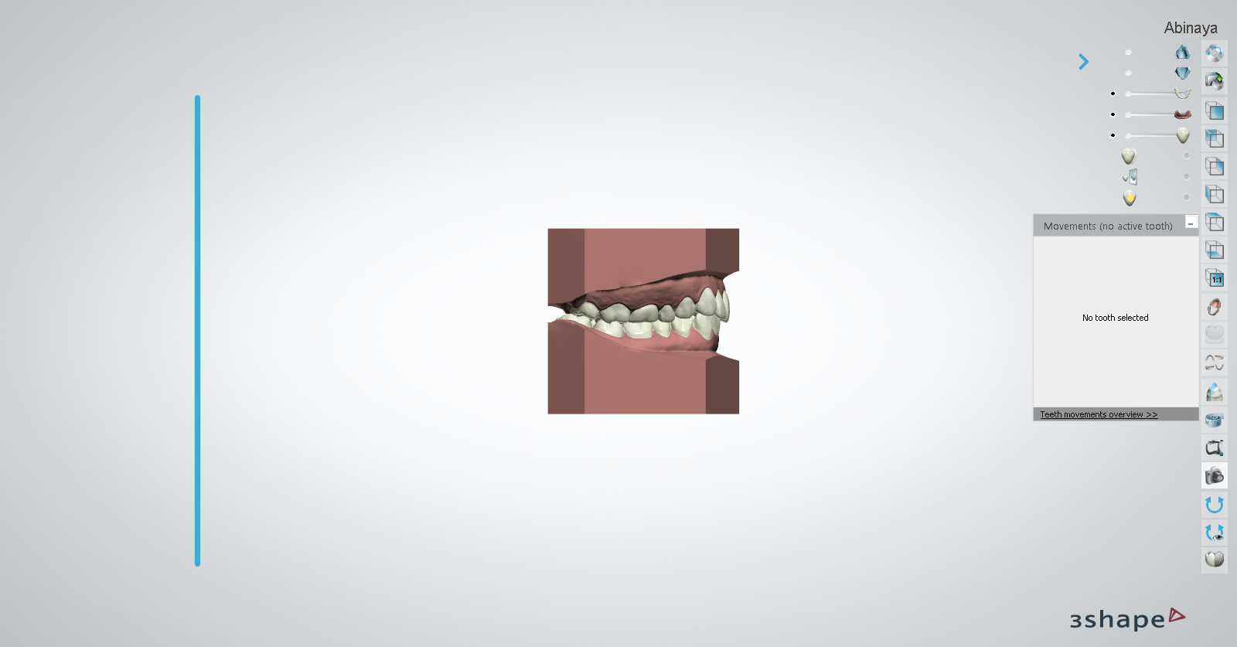**• Date:** 25‑01‑2022 19:26:06

**• Comment:**

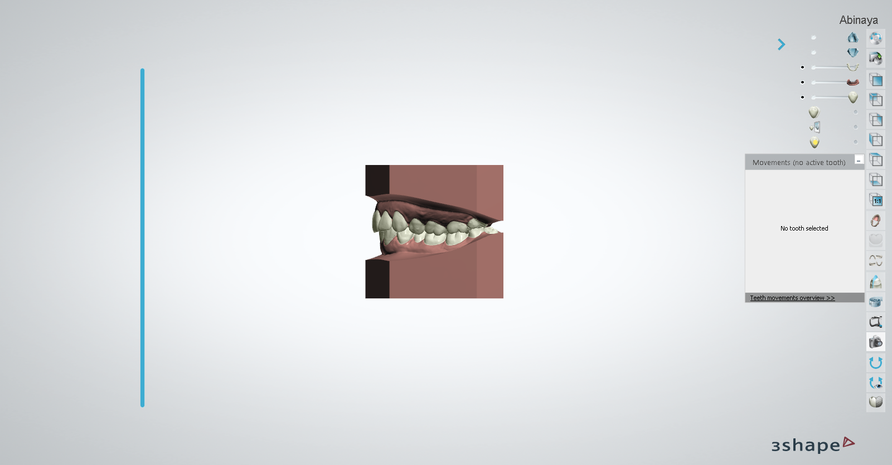**• Date:** 25‑01‑2022 19:26:12

**• Comment:**

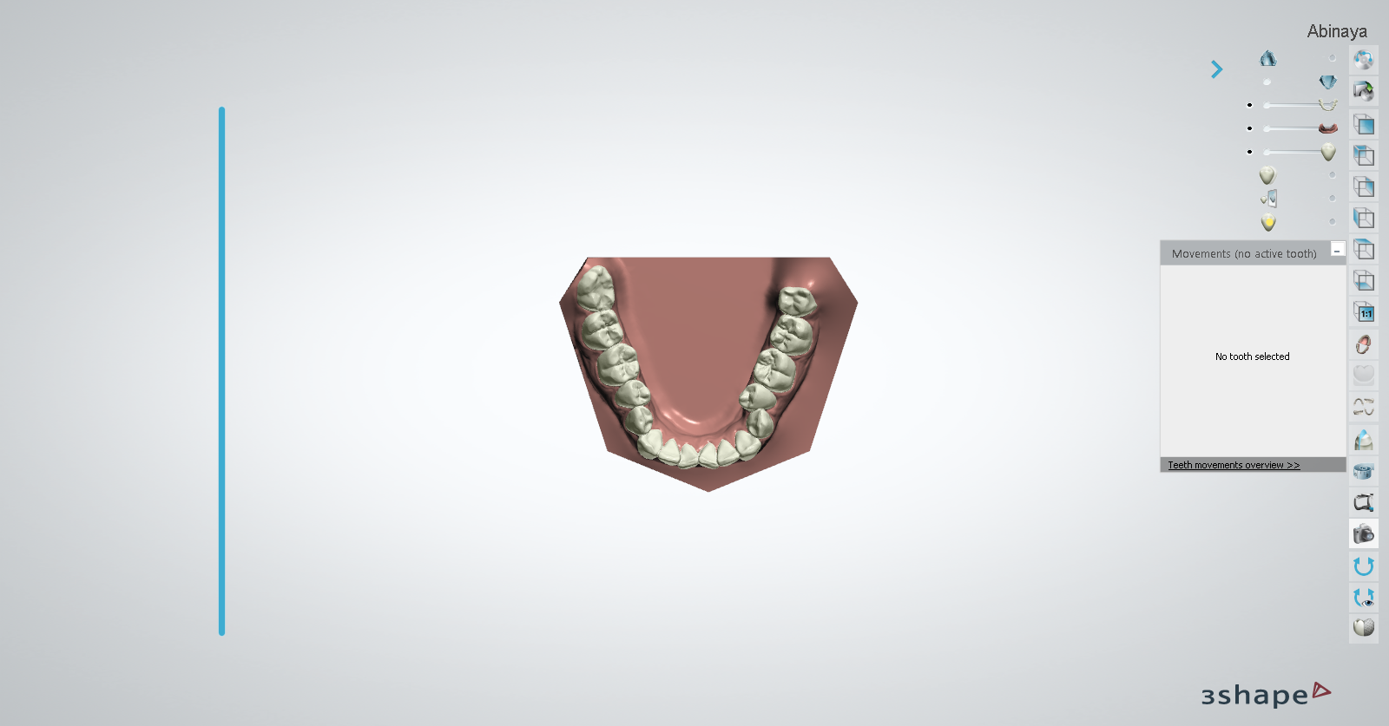Page 6 of 11



**• Date:** 25‑01‑2022 19:26:17

**• Comment:**

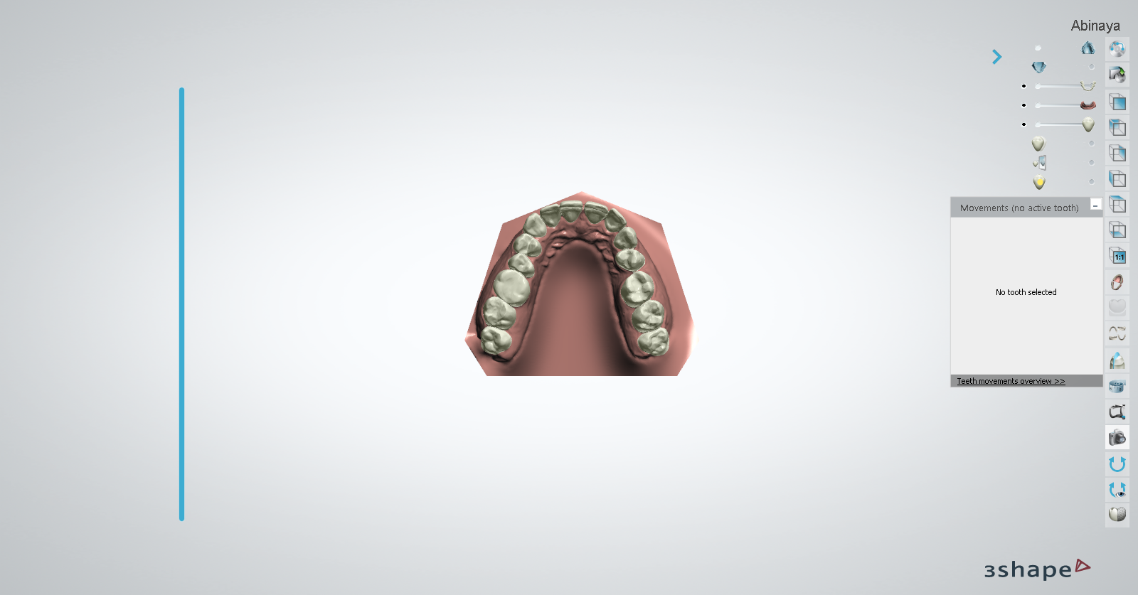**• Date:** 25‑01‑2022 19:26:37

**• Comment:**

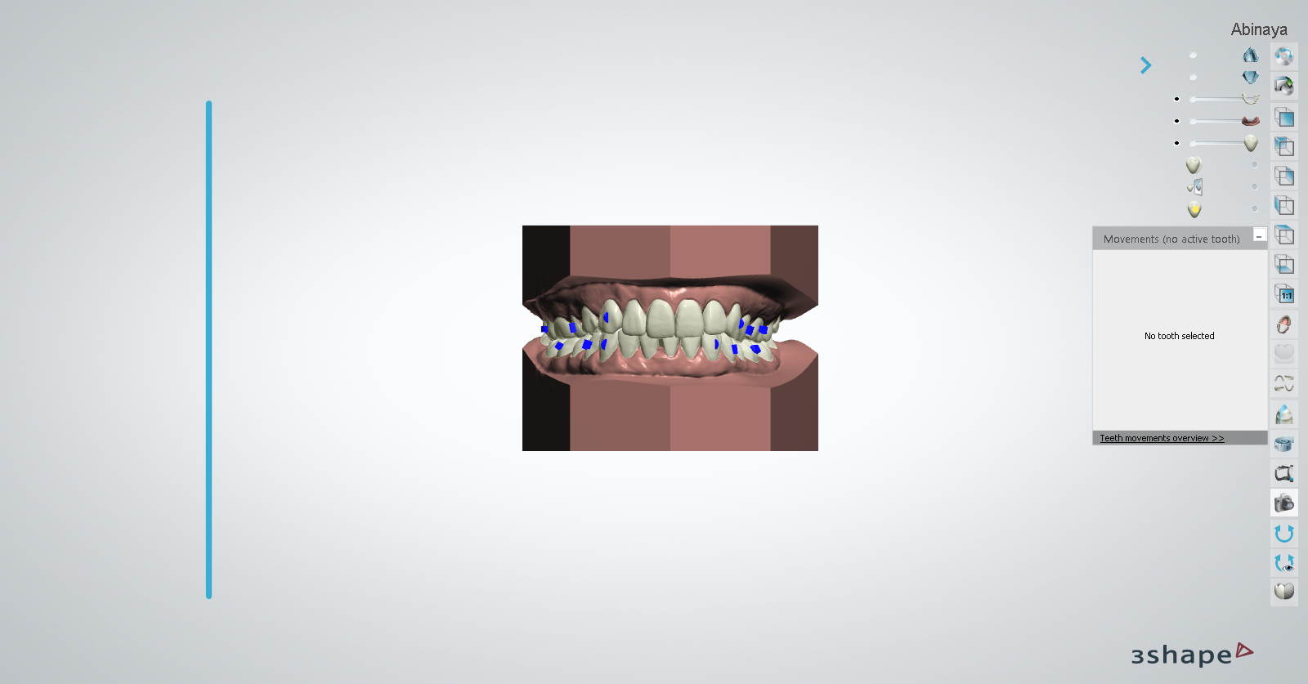**• Date:** 25‑01‑2022 19:27:18

**• Comment:**

Page 7 of 11



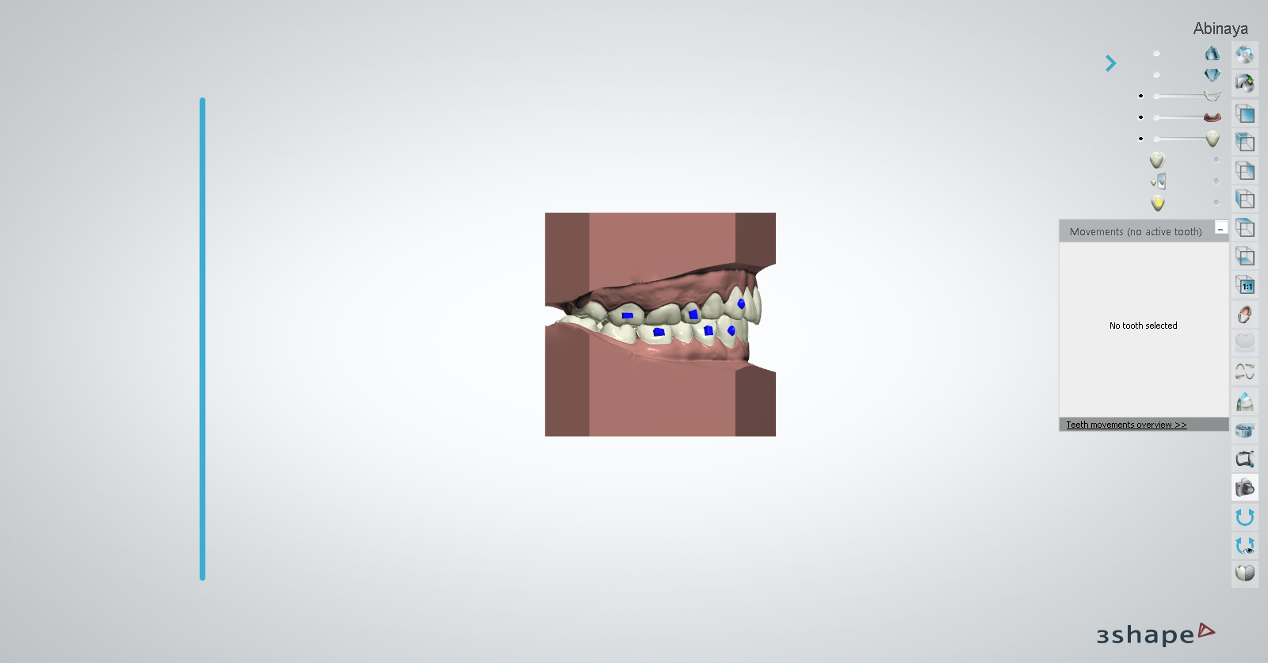**• Date:** 25‑01‑2022 19:29:07

**• Comment:**

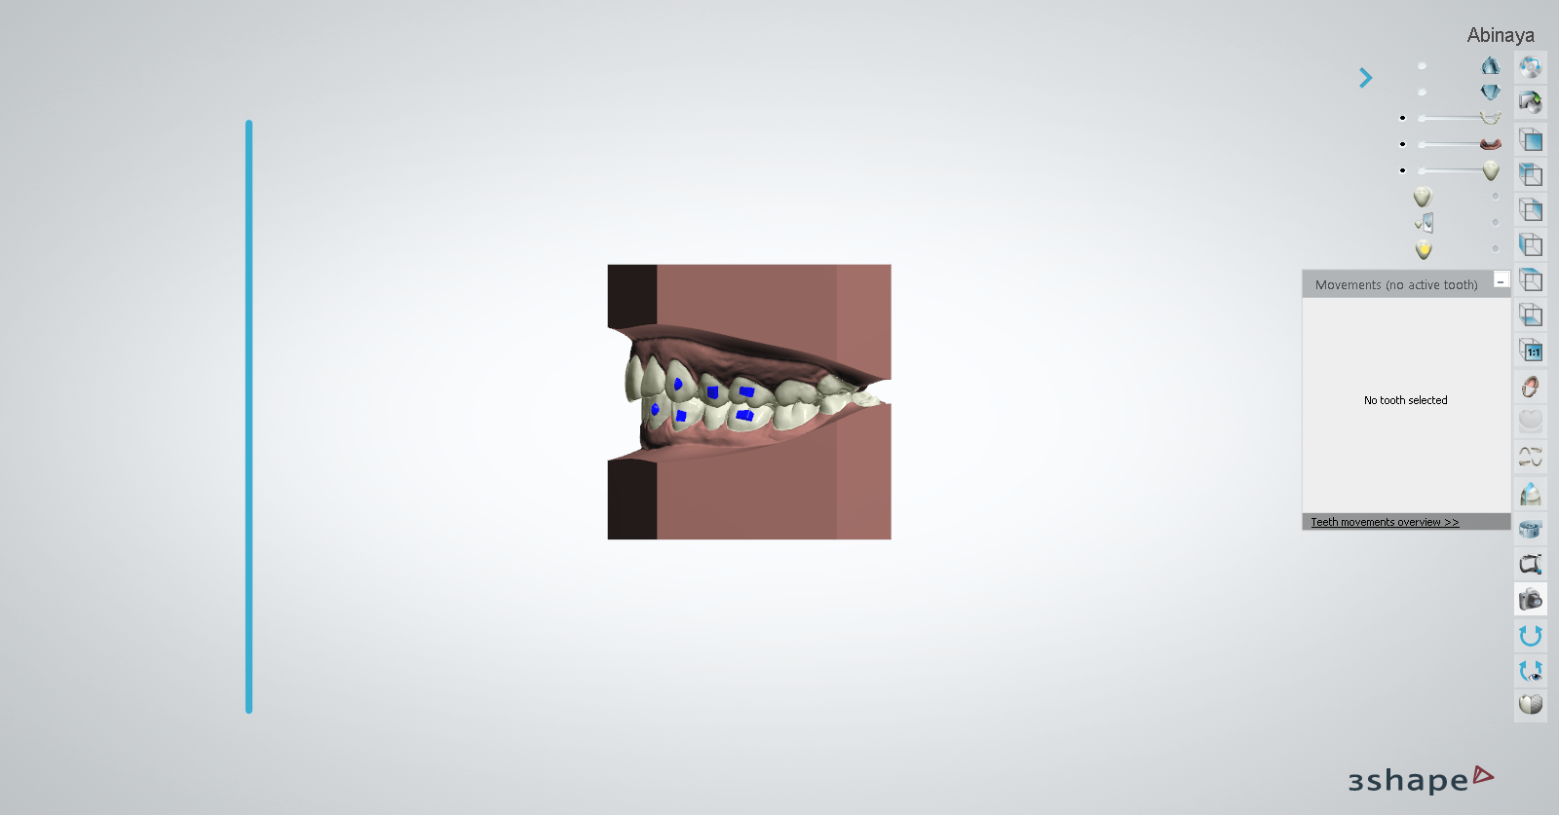**• Date:** 25‑01‑2022 19:30:41

**• Comment:**

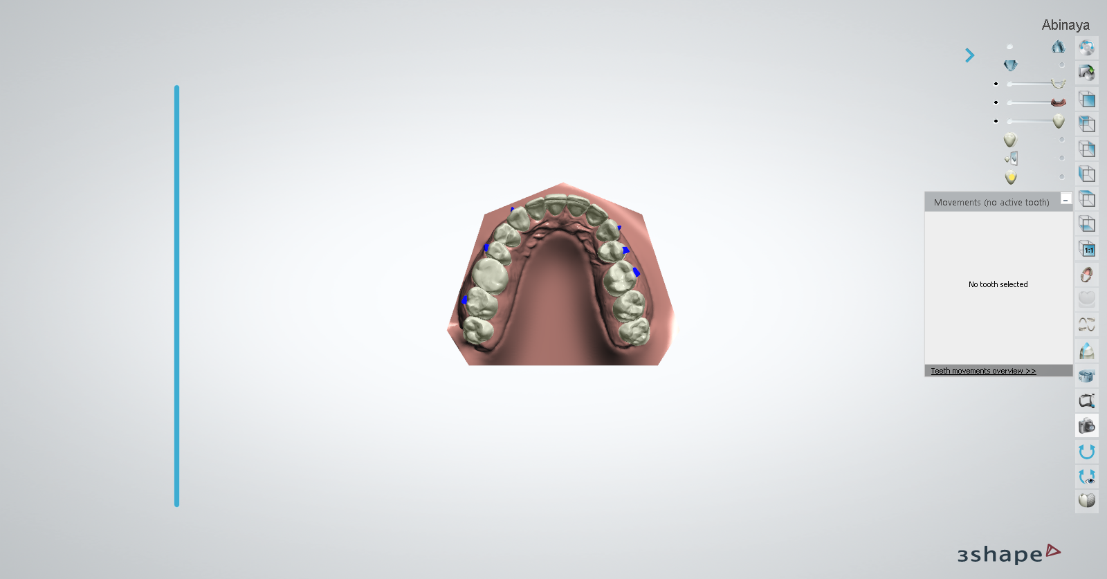Page 8 of 11



**• Date:** 25‑01‑2022 19:32:13

**• Comment:**

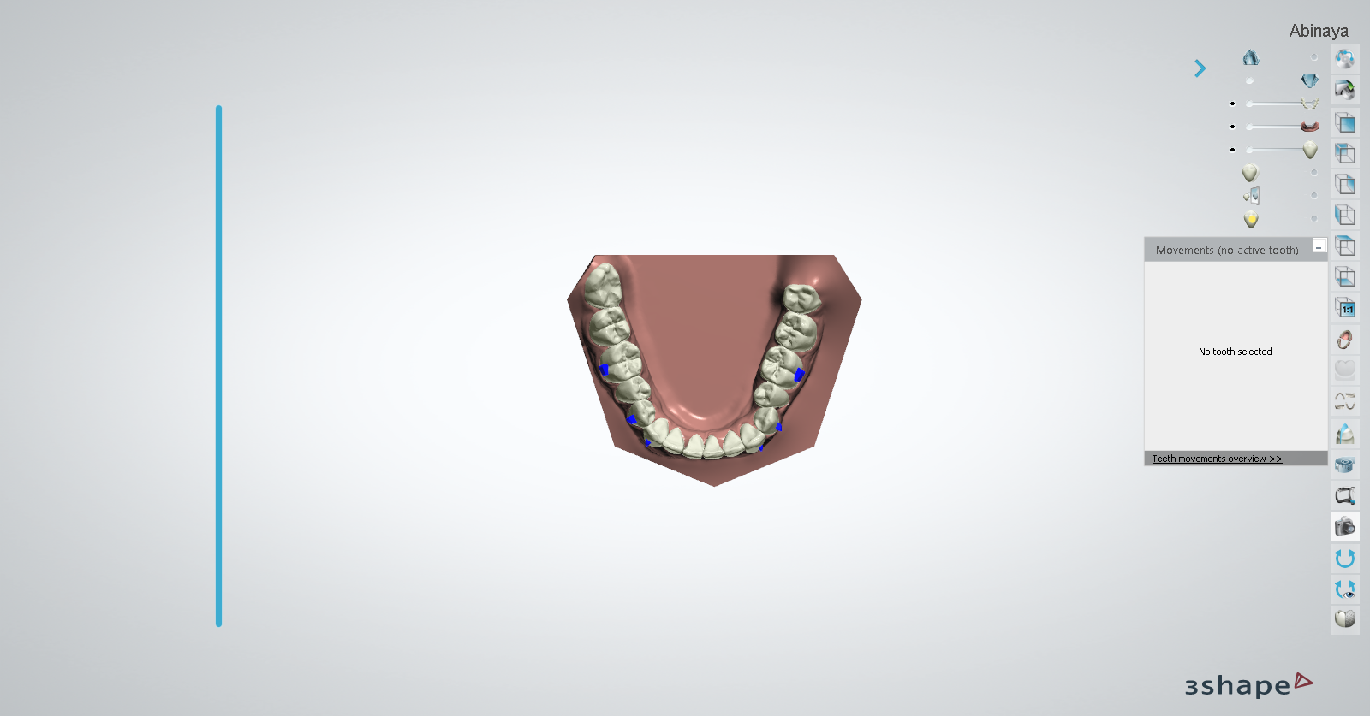**Schwartz Korkhaus Analyses** (Unweighted Total: **0,** Weighted Total: **0**)

UW: 0 W: x1 = 0

**Korkhaus Schwartz Maxilla**

Korkhaus A

23.27

**•**

Korkhaus B (Line Korkhaus U4_4)

value is undefined

**•**

Korkhaus B Ideal

34.00

**•**

Korkhaus B Discrepancy

value is undefined

**•**

Korkhaus C (Line Korkhaus U6_6)

value is undefined

**•**

Korkhaus C Ideal

43.50

**•**

Korkhaus C Discrepancy

value is undefined

**•**

Korkhaus D (Korkhaus Distance U1_1)

value is undefined

**•**

Korkhaus D Ideal

18.00

**•**

Korkhaus D Discrepancy

value is undefined

**•**

UW: 0 W: x1 = 0

**Korkhaus Schwartz Mandible**

Korkhaus B1 (Korkhaus Line L4_4)

value is undefined

**•**

Korkhaus B1 Ideal

34.00

**•**

Korkhaus B1 Discrepancy

value is undefined

**•**

Korkhaus C1 (Korkhaus Line L6_6)

value is undefined

**•**

Korkhaus C1 Ideal

42.50

**•**

Korkhaus C1 Discrepancy

value is undefined

**•**

Page 9 of 11



**Teeth Movement Report**

**Setup:**

Tooth Number

Rotation

Angulation

Incli‑ nation

Left/

Right

Extrusion/ Intrusion

Forward/ Backward

Long Axis

Circum‑ference

**25‑Jan‑22 3:17:55 PM**

IPR Distal (mm)

IPR Mesial (mm)

16

0.1 mm

1.3 mm

81.8 deg

36.9 mm

15

5.0 deg

‑0.1 mm

1.1 mm

75.8 deg

24.1 mm

14

‑6.4 deg

5.0 deg

76.7 deg

25.3 mm

13

‑14.8 deg

‑1.2 mm

60.4 deg

23.1 mm

12

4.6 deg

‑1.0 deg

0.8 mm

0.4 mm

‑0.9 mm

70.7 deg

19.5 mm

11

‑1.0 deg

1.0 mm

0.5 mm

‑0.4 mm

72.2 deg

20.9 mm

21

1.0 deg

‑0.4 mm

0.6 mm

‑0.8 mm

75.3 deg

21.4 mm

22

‑11.4 deg

‑2.0 deg

‑0.7 mm

1.0 mm

0.0 mm

65.6 deg

19.6 mm

23

0.5 deg

‑0.7 mm

0.1 mm

70.4 deg

22.2 mm

24

‑18.0 deg

‑2.4 deg

2.2 deg

‑0.2 mm

0.1 mm

0.1 mm

77.1 deg

25.0 mm

26

4.0 deg

75.4 deg

33.8 mm

36

‑3.3 deg

4.0 deg

‑0.1 mm

80.1 deg

33.5 mm

35

‑4.1 deg

12.0 deg

0.8 mm

69.5 deg

23.9 mm

34

‑17.2 deg

3.0 deg

0.1 mm

0.7 mm

83.0 deg

21.6 mm

33

2.1 deg

‑3.0 deg

‑0.3 mm

0.3 mm

76.9 deg

20.4 mm

32

‑1.6 deg

‑2.0 deg

‑0.6 mm

0.7 mm

‑0.5 mm

79.0 deg

16.7 mm

31

26.4 deg

2.0 deg

‑2.0 deg

0.1 mm

0.6 mm

‑0.1 mm

71.5 deg

15.7 mm

41

24.3 deg

‑0.1 mm

0.6 mm

‑1.2 mm

79.9 deg

15.6 mm

42

5.4 deg

‑1.2 mm

1.0 mm

‑1.3 mm

78.6 deg

16.7 mm

43

2.3 deg

‑1.4 mm

0.5 mm

‑1.1 mm

86.5 deg

20.8 mm

44

‑7.8 deg

‑1.1 mm

0.7 mm

0.7 mm

81.2 deg

21.5 mm

45

‑0.5 mm

0.4 mm

1.5 mm

68.8 deg

23.6 mm

46

1.1 mm

78.7 deg

32.8 mm

**Setup:**

Tooth Number

Rotation

Angulation

Incli‑ nation

Left/

Right

Extrusion/ Intrusion

Forward/ Backward

Long Axis

Circum‑ference

**upload plan**

IPR Distal (mm)

IPR Mesial (mm)

16

0.1 mm

1.3 mm

81.8 deg

36.9 mm

15

5.0 deg

‑0.1 mm

1.1 mm

75.8 deg

24.1 mm

14

‑6.4 deg

5.0 deg

76.7 deg

25.3 mm

13

‑14.8 deg

‑1.2 mm

60.4 deg

23.1 mm

12

4.6 deg

‑1.0 deg

0.8 mm

0.4 mm

‑0.9 mm

70.7 deg

19.5 mm

11

‑1.0 deg

1.0 mm

0.5 mm

‑0.4 mm

72.2 deg

20.9 mm

21

1.0 deg

‑0.4 mm

0.6 mm

‑0.8 mm

75.3 deg

21.4 mm

22

‑11.4 deg

‑2.0 deg

‑0.7 mm

1.0 mm

0.0 mm

65.6 deg

19.6 mm

23

0.5 deg

‑0.7 mm

0.1 mm

70.4 deg

22.2 mm

24

‑18.0 deg

‑2.4 deg

2.2 deg

‑0.2 mm

0.1 mm

0.1 mm

77.1 deg

25.0 mm

26

4.0 deg

75.4 deg

33.8 mm

36

‑3.3 deg

4.0 deg

‑0.1 mm

80.1 deg

33.5 mm

Manual

Manual

35

‑4.1 deg

12.0 deg

0.8 mm

69.5 deg

23.9 mm

Manual

Manual

34

‑17.2 deg

3.0 deg

0.1 mm

0.7 mm

83.0 deg

21.6 mm

Manual

Manual

33

2.1 deg

‑3.0 deg

‑0.3 mm

0.3 mm

76.9 deg

20.4 mm

Manual

Manual

32

‑1.6 deg

‑2.0 deg

‑0.6 mm

0.7 mm

‑0.5 mm

79.0 deg

16.7 mm

Manual

Manual

31

26.4 deg

2.0 deg

‑2.0 deg

0.1 mm

0.6 mm

‑0.1 mm

71.5 deg

15.7 mm

Manual

Manual

Page 10 of 11



41

24.3 deg

‑0.1 mm

0.6 mm

‑1.2 mm

79.9 deg

15.6 mm

Manual

Manual

42

5.4 deg

‑1.2 mm

1.0 mm

‑1.3 mm

78.6 deg

16.7 mm

Manual

Manual

43

2.3 deg

‑1.4 mm

0.5 mm

‑1.1 mm

86.5 deg

20.8 mm

Manual

Manual

44

‑7.8 deg

‑1.1 mm

0.7 mm

0.7 mm

81.2 deg

21.5 mm

Manual

Manual

45

‑0.5 mm

0.4 mm

1.5 mm

68.8 deg

23.6 mm

Manual

Manual

46

1.1 mm

78.7 deg

32.8 mm

Manual

Manual

Page 11 of 11

